Product Overview:
The WIN-MD-RS232-RS485 is a highly reliable, bidirectional communication converter designed to seamlessly bridge standard RS232 devices with long-distance, multi-drop RS485 networks. It is ideal for industrial automation, PLC integration, and access control systems, enabling stable data transmission over extended distances with high resistance to electrical noise and interference.
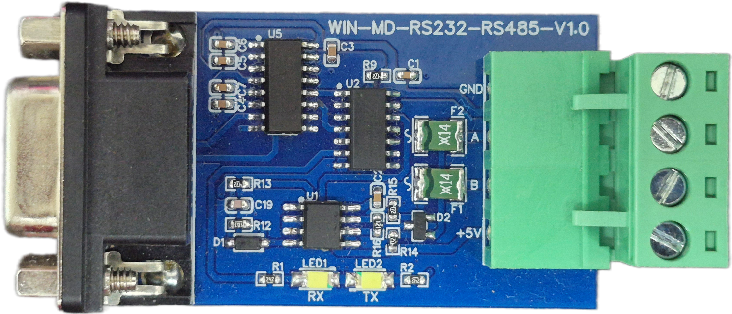

A key advantage of the WIN-MD-RS232-RS485 is its compact, plug-and-play architecture. The module features a standard DB9 connector for the RS232 interface alongside a secure 4-pin screw terminal block (A, B, GND, +5V) for the RS485 network and power input. To streamline installation and field diagnostics, the board is equipped with onboard TX (Transmit) and RX (Receive) LED indicators that provide real-time visual confirmation of data traffic.

Engineered for dependable performance in diverse industrial IoT applications, this converter effortlessly extends the reach of legacy serial equipment. It allows users to quickly and efficiently integrate single-node RS232 hardware into robust RS485 topologies without requiring complex software configurations.

General Specification:
- Product dimension: 55*32*19 mm.
- Power supply DC: 5V DC

- Certifications:


Modbus RS-485
Modbus RS-232
Polling LED

Contact Information
Augmatic Technologies Pvt. Ltd.,
Plot no 6, Shah Industrial Estate II,
Kotambi,
Vadodara – 391510.
Email – Sales@wittelb.com
Support: support@wittelb.raiseaticket.com / +91 94038 92805

